


Doors and Windows Standardisation

IIA (Northern Chapter) and CCPS Initiative

Background Note

A. Introduction

We all know that to realise the full potential of the construction industry, we need to bring greater standardisation into practice. Having recognised that the doors and windows and their related components as important products which can be standardised early, CCPS and IIA (Northern Chapter) has launched the Doors and Windows Standardisation Initiative.

However, the sizes are only recommendatory not mandatory. It is for most often used sizes of doors and windows, leaving full scope for innovations.

B. Objective

The initiative seeks to:

- List the types of doors & windows elements that must be taken up for standardisation under the initiative.
- Generate consensus on a set of standard sizes for doors and windows elements, suitable for the Indian construction industry.
- Identify potential pilot projects and push for the use of standard sizes for doors and windows
- Encourage manufacturers to produce standard-sized doors and windows
- Generate increased awareness of the benefits of standardised components in order to create a wider demand in the industry for standard sized doors and windows.

C. Benefits

The potential benefits of standardisation are:

- It will provide impetus to for production of off-site manufactured products and reduce uncertainities associated with in-place construction.
- It will bring economies of scale, increase quality and reduce the wastage.
- It will facilitate the production of technologically improved products and also the incorporation of new technologies for fixing, in daily practice.
- It will provide more options to the customer for the ready made doors make the architect’s work easier and reduce the inventory costs of manufacturers and builders.
- It will help in emergence of an organised market for ready to fit related products like curtain rods, blinds, pre-fabricated lintels etc.
- The improvements in the components of doors and windows will enhance the skills and working conditions of the workers and thus their efficiency will also go up.

D. Present Situation

The trend in India is more of made to order doors and windows, resulting in high wastage and limited choice, often making it difficult to achieve quality on site.

E. Recommended Sizes

We are recommending to adopt a set of standard sizes of finished masonry opening for doors and windows. The recommendations are based on the common sizes that are required most often.

E.1.1. Doors

- We recommend standardising the opening sizes for the doors i.e. finished masonry opening. In which the complete unit of door i.e. shutter with frame can be fixed post construction. It will eliminate the onsite job work and also the hassles of procuring the shutter and frame from different places. The options of the sizes for different purposes are given in the survey form.
- To achieve the precision in measurement at actual site, we recommend the use of sub frame.
- There is scope for standardising the sections of wooden frames for doors, which will be taken up in the next stage.
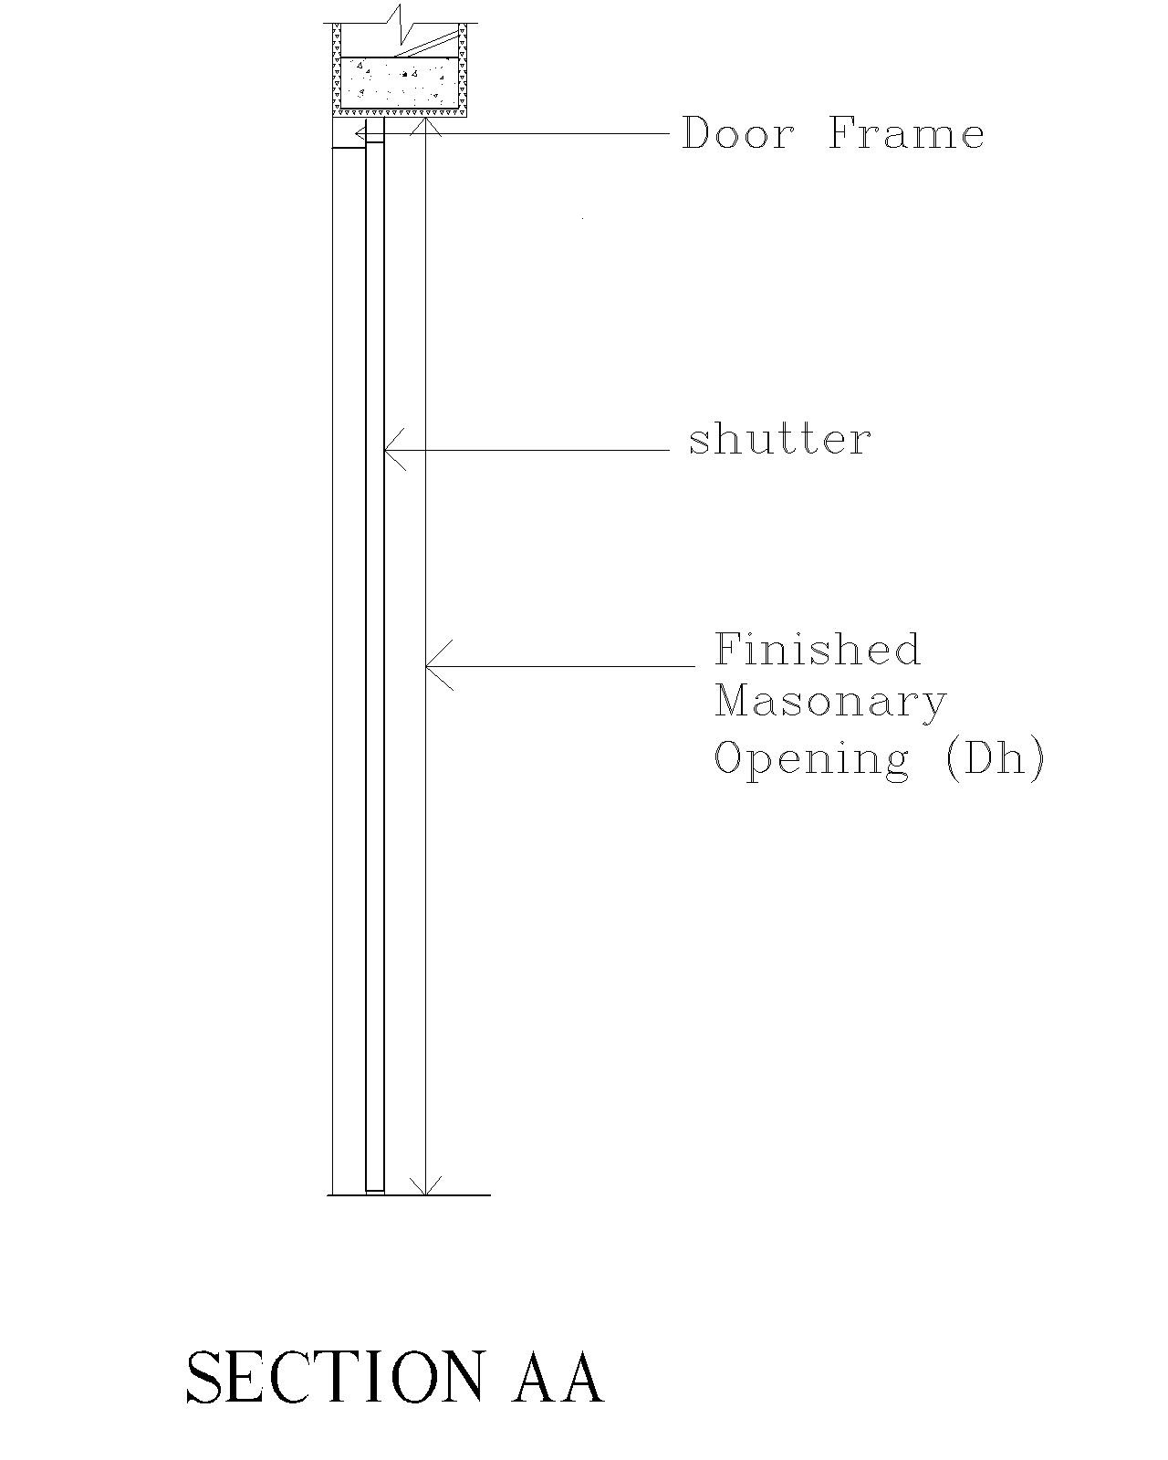
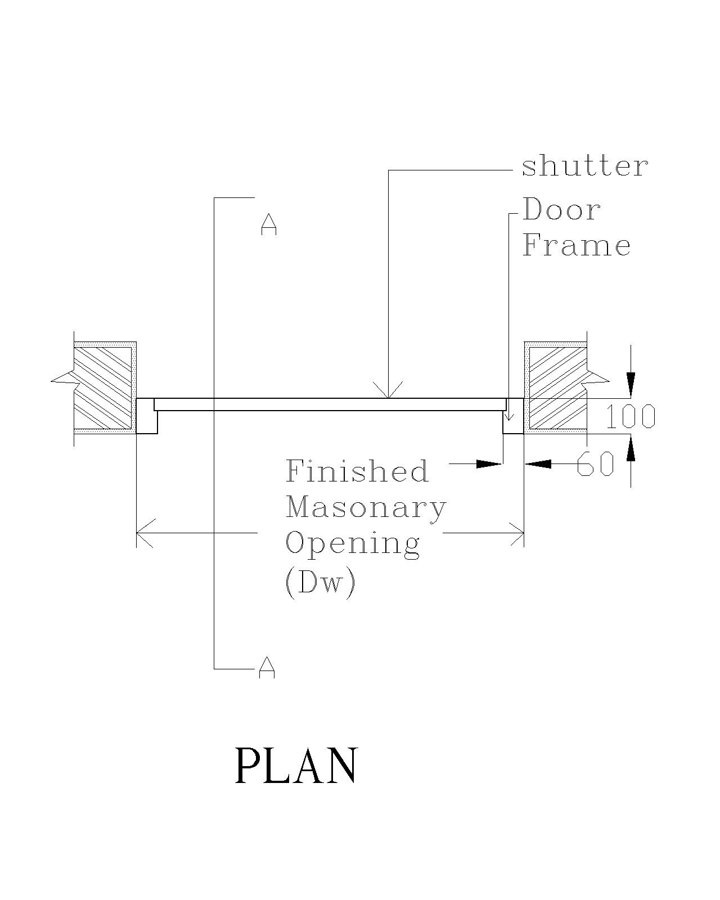

E.2. Windows

- We are proposing standard sill level and lintel level. And on this basis we are recommending a set of sizes (listed in the survey form attached with it) that can be used most often.
- The standard size of the finished masonry opening for windows allows the use of prefabricated windows made up of any material as integral unit.
- These sizes can be promoted for the maximum usage.
- There can be several other sizes that would be used according to the design considerations of the building. It is up to industry to come up with enough options in this regard.
- For windows also, to achieve the precision in measurement at actual site, we recommend the use of sub frame.

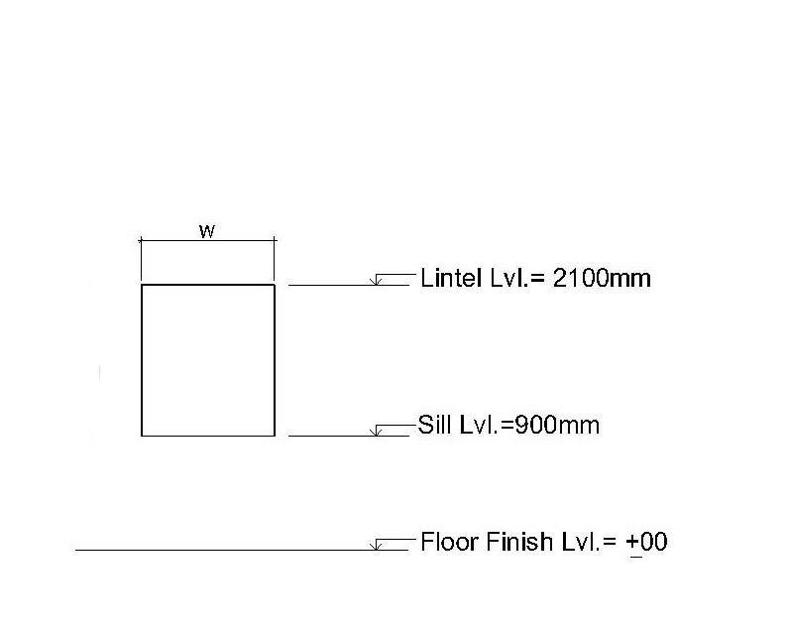

F. Explanatory Notes to Survey Form:

¹ Distance between the finished surfaces in masonry work for door opening in which door frame with door shutter can be fixed.

² Distance between the finished surfaces in masonry work for window opening in which window frame with window panes can be fixed.

³ Level at which the window frame is fixed (measured from Floor Finish level).

⁴ Window having horizontally openable hinged shutter.

G. Attached

1. Survey for Standardisation of Door and Window Dimensions.

Prepared by: Confederation of Construction Products and Services (CCPS).
Thursday, October 07, 2004

© Confederation of Construction Products and Services

For comments / further details please contact Mr. Deepak Gahlowt, Convener, or Mr. Amit Chandra Agarwal, Architect, Confederation of Construction Products and Services, C-40/A Gangotri Enclave, Alaknanda, New Delhi – 110019. Phone +91 11 26445615, Fax +91 11 26216709.

